**Objective:**

This document describes essential information for configuring routers, including address breakdowns and subnetting. A basic understanding of binary and decimal numbers is recommended. The document includes examples to illustrate how to assign IP addresses and subnets, and it provides detailed explanations of subnet masks, subnetting, and Classless Interdomain Routing (CIDR). Examples demonstrate how to determine if devices are on the same subnet and how to efficiently use address space with Variable Length Subnet Masks (VLSM).

**Additional Information About Terms:**

* Address: Unique number ID for a host/interface in a network.
* Subnet: Portion of a network with a specific subnet address.

**Understanding IP address:**

* IP Address: Unique identifier for a device on an IP network, expressed in dotted decimal format (e.g., 172.16.81.100).
* Example: IP address 192.168.1.1 in binary is 11000000.10101000.00000001.00000001.
* Subnetting: Dividing a major network into smaller sub-networks (subnets) using an extended subnet mask.
* Example: For network 192.168.5.0/24, subnet into 192.168.5.0/27, 192.168.5.32/27, etc.

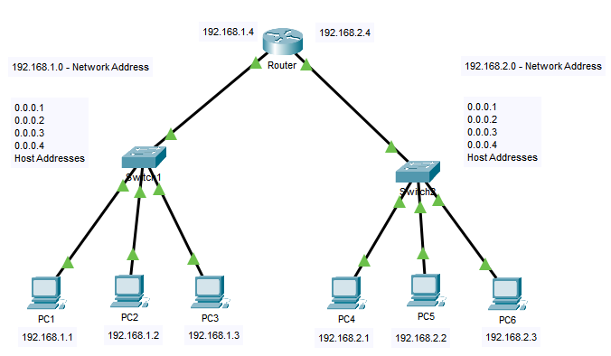

**Differences between IPV4 and IPV6**:

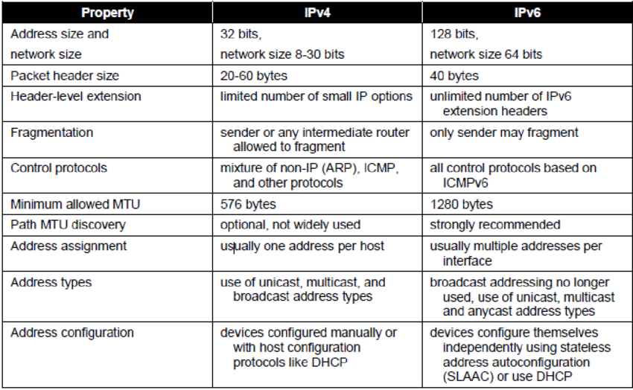

**Network Classes**:

IP addresses are categorized into classes (A, B, C) based on the range and default subnet masks, each suitable for different network sizes.

**Variable Length Subnet Masks(VLSM)**:

VLSM allows the use of different subnet masks within the same network, optimizing address space by varying the number of bits used for subnetting**.**

**Example:** For network 192.168.5.0/24, subnet requirements:

* netA: 192.168.5.0/28 (14 hosts)
* netB: 192.168.5.32/27 (28 hosts)
* netC: 192.168.5.64/30 (2 hosts)

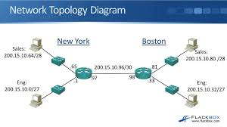

**Classlesss Addressing and CIDR:**

CIDR: Enhances address space utilization and routing scalability by using a prefix/length notation (e.g., 172.16.0.0/16).

Example: ISP with 172.16.0.0/16 can allocate 172.16.1.0/24, 172.16.2.0/24 to customers.

CIDR also depicts a more hierarchical Internet architecture, where each domain takes its IP addresses from a higher level. This allows for the summarization of the domains to be done at the higher level. For example, if an ISP owns network 172.16.0.0/16, then the ISP can offer 172.16.1.0/24, 172.16.2.0/24, and so on to customers. Yet, when advertising to other providers, the ISP only needs to advertise 172.16.0.0/16.

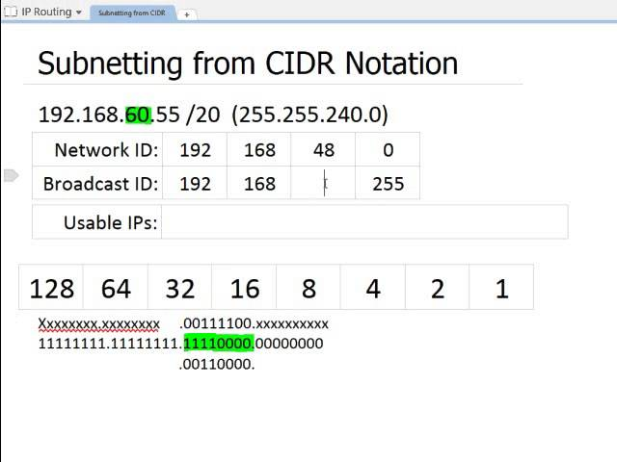

**Karan Tolambiya**

**25-05-2024**